El Saadawi, Nawal (1931-)

Yaser Mirdamadi, University of Edinburgh


SUMMARY
Nawal El Saadawi is a renowned Egyptian writer, novelist, feminist activist, political dissident, physician and psychiatrist. The main themes of her works are the suppression and suffering of women in a patriarchal society backed by religion. She is specifically famous for her struggle against female circumcision. She is regarded as one of the most radical feminists of the Arab and Muslim world.
Nawal El Saadawi at the age of 80
url: http://www.theguardian.com/world/2011/mar/08/nawal-el-saadawi-100-women

MAIN ENTRY

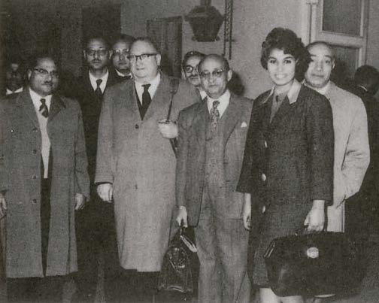
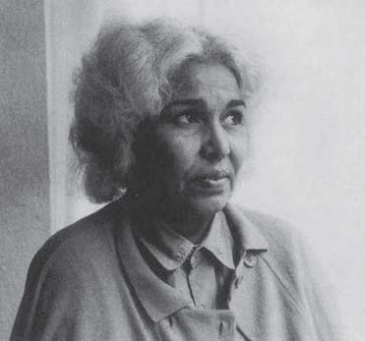
Nawal El Saadawi was born in 1931 in a village called Kafir Talha in the delta region of Egypt. Her father was a civil servant and her mother came from an upper-class family. She was forced to undergo circumcision when she was 6 years old. Nawal studied medicine at the university of Cairo. She graduated in 1955 and first practiced as a physiatrist. She was appointed in 1958 to the Ministry of Health. In 1966 she received a Master of Public Health degree from Columbia University and became director of public health. In 1972, after the publication of her taboo-breaking first work of non-fiction,Woman and Sex, and specifically her protest in this book against female circumcision and its relation to religion, she lost her job. She was also dismissed of her jobs as editor-in-chief of the journal Health and assistant general secretary in the Medical Association in Egypt. From that time onwards she has been engaged in an inexhaustible and long-standing struggle for freedom of expression and women’s emancipation in Egypt and more generally the Arab and Muslim world. In 1979–80 she served as the United Nations Adviser for the Women’s Program in Africa and the Middle East. In 1981 she was captured and imprisoned for two months after she criticised the one-party rule of Egyptian president Anwar Sadat. Inspired by her imprisonment, she wrote her novel The Fall of the Imam. Just after her release she founded a NGO and a feminist organization called the Arab Women's Solidarity Association (AWSA) that was devoted to the problems of women. The Egyptian government in 1991 closed down AWSA and due to the pressures put on her by Muslim fundamentalists in 1992 she went into exile. From 1988 till 1993 her name appeared on death lists issued by Muslim fundamentalist groups. In the USA she taught at Duke University in North Carolina and Washington State University in Seattle. In 1997 she returned to Egypt.
Nawal El Saadawi among male doctors,
Ministry of Health, Cairo 1963.
Taken from: A Daughter of Isis: The Autobiography of Nawal El Saadawi. London: Zed Books, 1999, p. 353.

Nawal El Saadawi in Prison in 1981
Taken from: A Daughter of Isis: The Autobiography of Nawal El Saadawi. London: Zed Books, 1999, p. 32.
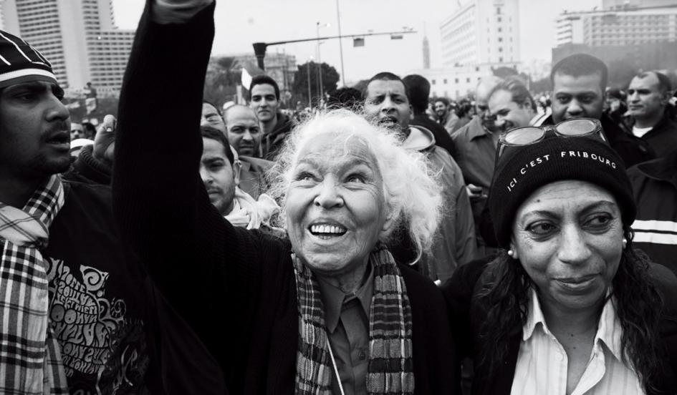
Once again, however, she faced trouble in 2001 when in an interview she suggested that Islamic pilgrimage has its origins in a pagan tradition, and emphasised that the Islamic law of inheritance is discriminatory toward women. She was consequently accused of apostasy and a lawyer tried to force her to divorce her husband since according to Islamic law a non-Muslim cannot marry or continue his/her marriage with a Muslim, although the case was not eventually successful. Yet another case in 2008 demanded the withdrawal of her Egyptian nationality because of her play God Resigns at the Summit Meeting that was published in Cairo in 2007. When protests in Egypt, as a part of what is called ‘the Arab Spring’ began, she attended protests in the famous public square in Cairo called Tahrir. In a 2010 interview she expressed her view about veiling suggesting that ‘the veil should be banned’. She also frequently considered religions (Islam as well as other religions) as patriarchal and the main source of oppression against women. She was awarded, among other awards, the 2004 North-South Prize by the Council of Europe. She has published over forty books and her books have been translated into over twenty languages. Her most famous novel, Woman at Point Zero, was published in Beirut in 1973 and translated into English by her husband Sherif Hetata in 1983. The common themes of her fiction and non-fiction works are the suppression and suffering of women backed by religions. Her approach toward religion, that is reminiscent of that of Richard Dawkins, has continued to be the subject of much heated criticism inside and outside Egypt.
Guardian’s interview with Nawal El Saadawi (a short video and text):

http://www.theguardian.com/lifeandstyle/2010/apr/15/nawal-el-saadawi-egyptian-feminist
Nawal El Saadawi among protesters in Tahrir Square in 2011
url: http://www.newsweek.com/feminists-tahrir-square-66139

List of Her translated works:

- The Hidden Face of Eve [Study] (London: Zed Books, 1980), reissued 2008
- Woman at Point Zero [novel] (London: Zed Books, 1982), reissued 2008
- God Dies by the Nile [novel] (London: Zed Books, 1984) reissued 2008
- Circling Song [novel] (London: Zed Books, 1986) reissued 2008
- The Fall of Imam [novel] (London: Methuen, 1987) Saqui Books London 2001, 2009.
- Searching [novel] (London: Zed Books, 1988) reissued 2008
- Death of an Ex-minister [short stories] (London: Methuen, 1987)
- She has no Place in Paradise [short stories] (London: Methuen, 1987)
- My Travel Around the World [non-fiction] (London: Methuen, 1985)
- Memoirs from the Women’s Prison [non-fiction] (London: Women’s Press, 1985) (also: University of California Press, USA, 1995)
- Two Women in One [novel] (London: Saqi, 1992) reissued 2013.
- Memoirs of a Women Doctor [novel] (London: Methuen, 1994) (also: City Lights, USA, 1993)
- The Well of Life [two novels] (London: Methuen, 1994)
- The Innocence of the Devil [novel] (London: Methuen, 1994) (also: University of California Press, 1995)
- Nawal El Saadawi Reader [non-fiction essays] (London: Zed Books, 1997)
- Vol 11 Nawal El Saadawi Reader (Zed Books, 2009)
- Part I A Daughter of Isis [autobiography] (London: Zed Books, 1999) reissued 2008
- Part II Walking Through Fire [autobiography] (London: Zed Books, 2002) reissued 2008
- Love in the Kingdom of oil [novel] (London: Alsaqui Books, 2001)
- The Novel [novel] (Northampton, Mass: Interlink Books, 2009)
- Zeina [novel] (London: Saqi Books, 2011)

Further Reading:

Ṭarabishi, Jurj, and Nawal Saʻdawi. Woman Against Her Sex: A Critique of Nawal El-Saadawi with a Reply by Nawal El-Saadawi. Saqi Books, 1988.

Royer, Diana. A Critical Study of the Works of Nawal El Saadawi, Egyptian Writer and Activist. Edwin Mellen Press, 2001.

Faulkner, Rita. National Allegory: Land and Body in Nawal El Saadawi and Assia Djebar. University of Illinois, 2005.

Mohammed, Razinat. Intra-Gender Relations Between Women: A Study of Nawal El-Saadawi and Buchi Emecheta’s Novels. Lap Lambert Academic Publishing, 2012.

